**Assignment-1**

1. Create file in local  
2. Move file from local to hdfs  
3. Rename file  
4. Delete some file

**NAME: Induja, D (CONTRACTOR)**

**ID: 2319849**



**Step 1:** Created one Folder at Local level (local_indu)

Command: mkdir local_indu

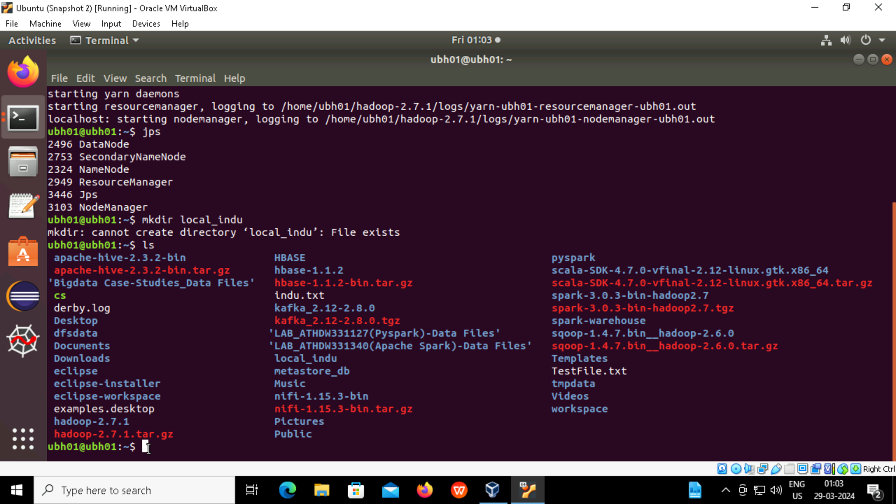

**Step 2**: Inserting two files (movies.item, ratings.data) from github into local and moving those two files into (local_indu) folder.

movie data link: wget <https://raw.githubusercontent.com/deeksharm/DP203/main/movies.item>

rating data link: wget <https://raw.githubusercontent.com/deeksharm/DP203/main/ratings.data>

Command: mv movies.item ratings.data local_indu

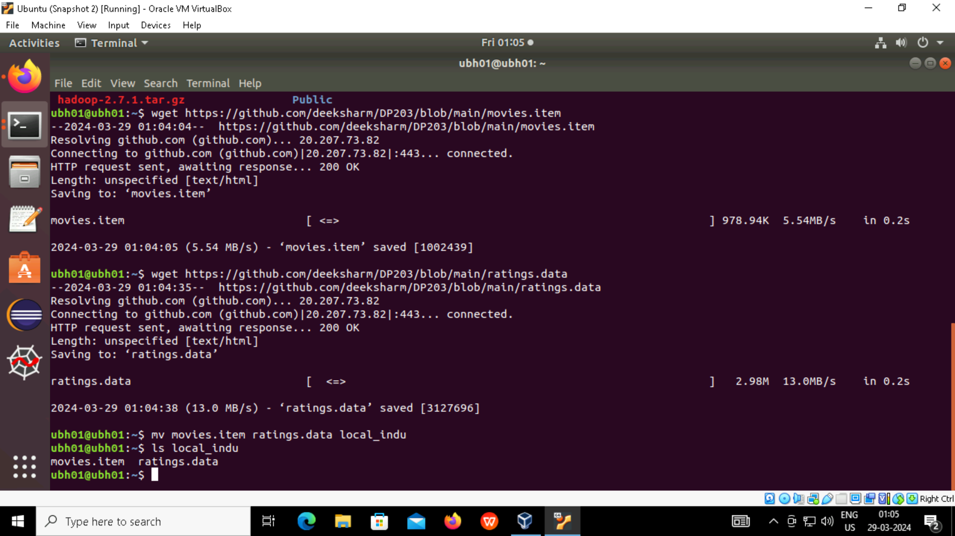

**Step 3**: created one folder in Hadoop (Indu)

Command: hdfs dfs -mkdir /Indu

Copying (movies.item,ratings.data) files from local folder to Hadoop folder(Indu).

Command: hdfs dfs -copyFromLocal local_indu/movies.item /Indu

hdfs dfs -copyFromLocal local_indu/ratings.data /Indu

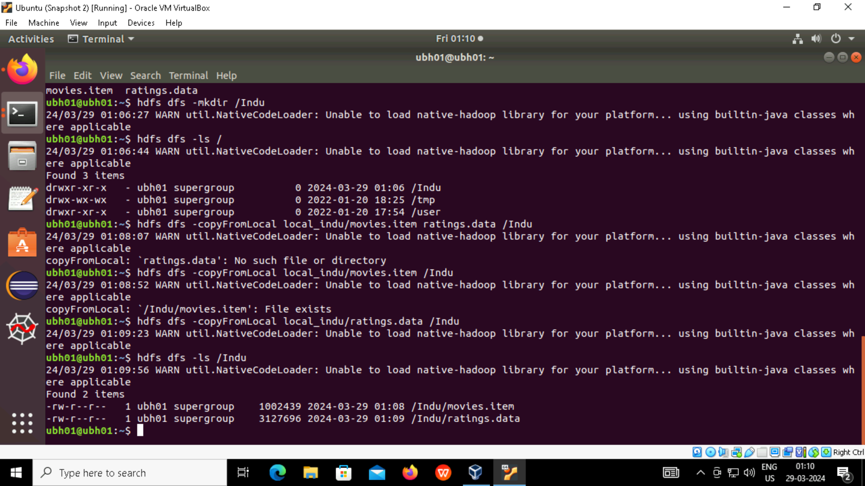

**Step 4**: Renaming (movies.item,ratings.data) files to (movies.csv,ratings.csv)

Command: hdfs dfs -mv /Indu/movies.item /Indu/movies.csv

**Step 5**: Deleting (movies.item,ratings.data)files in local level and (movies.csv,ratings.csv).

